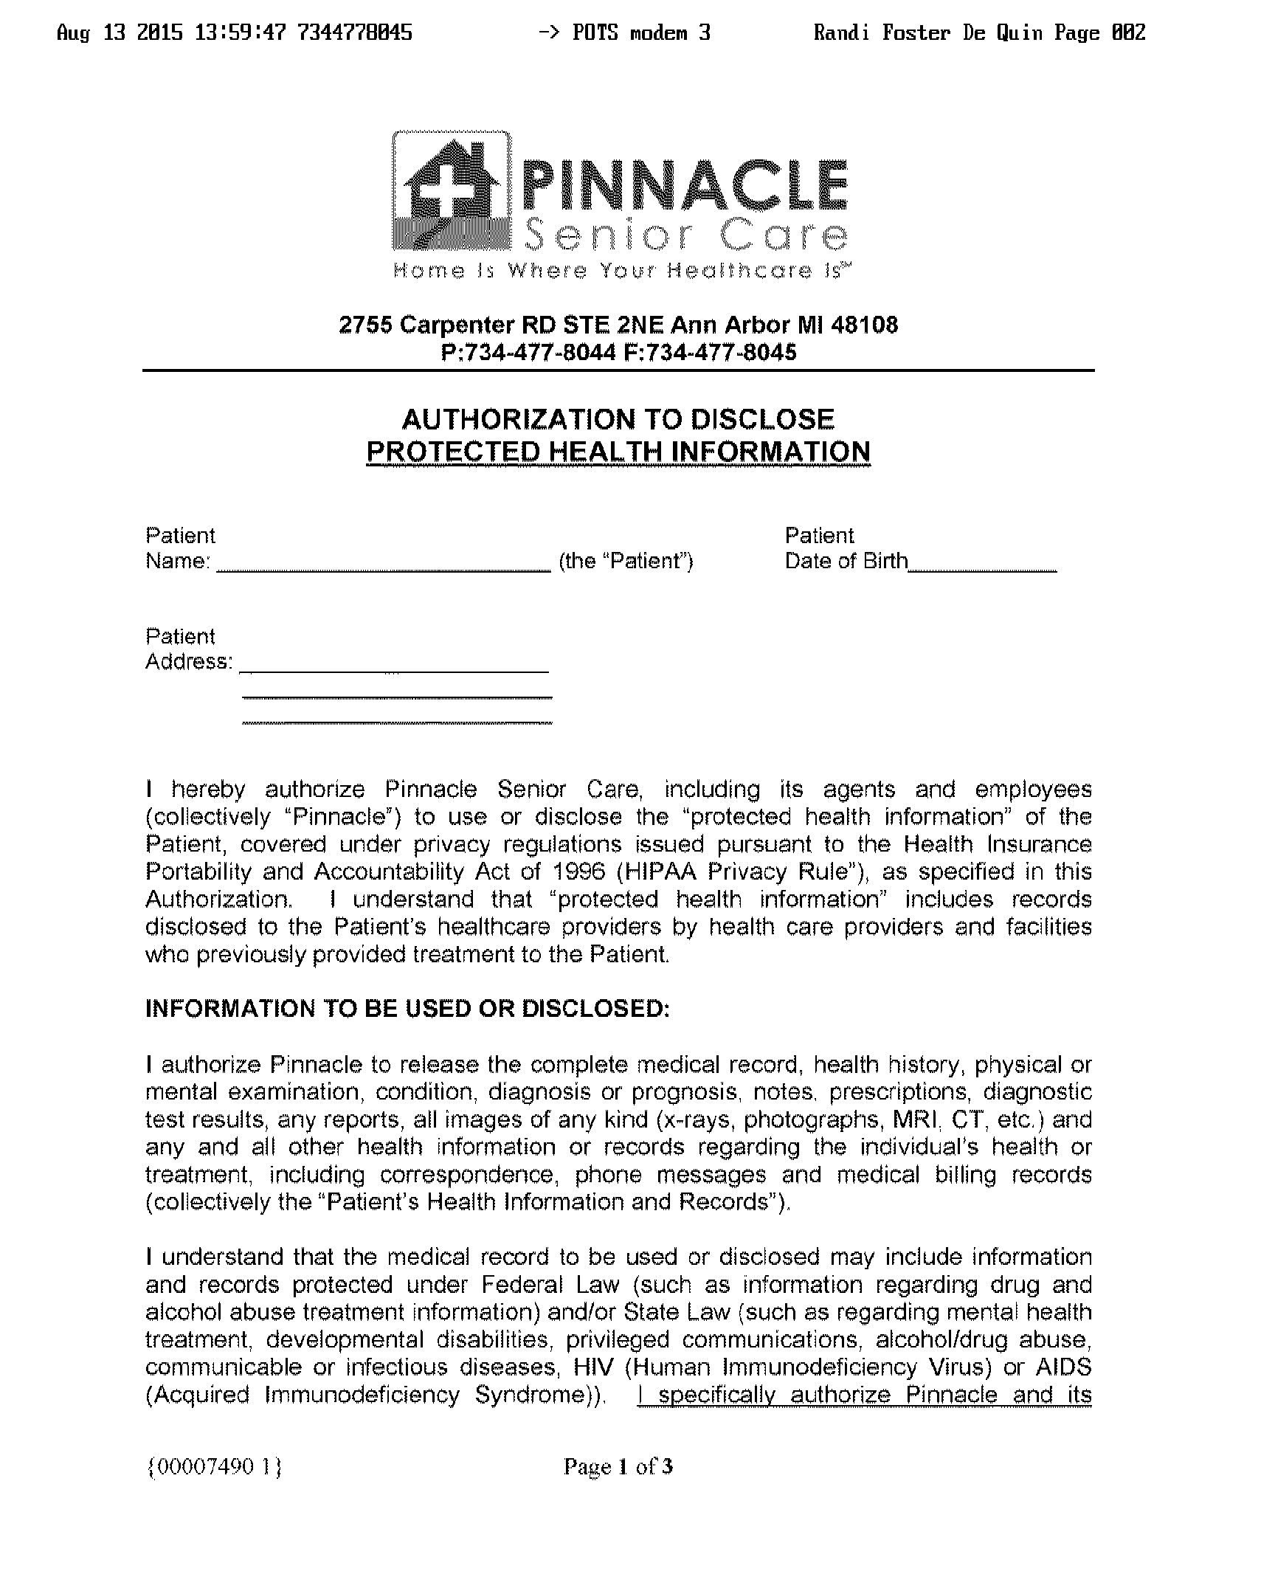
Patricia Martell

01/03/1953

,
Order Number 01-34762-001
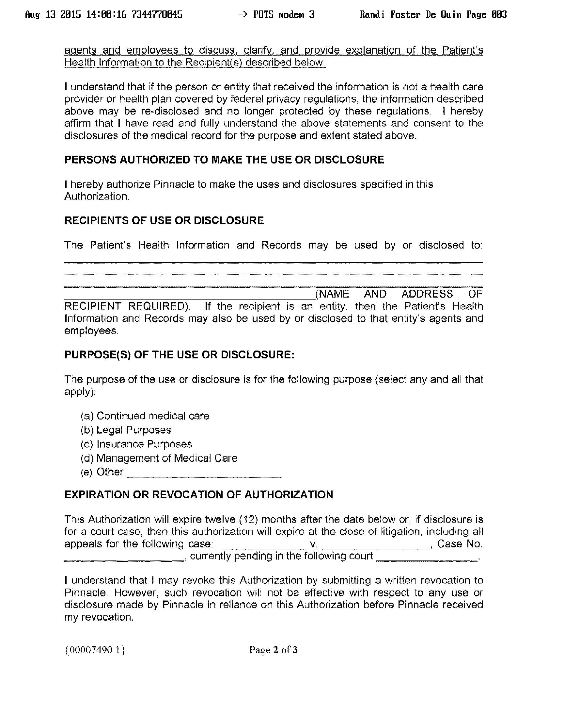
Order Number 01-34762-001

Axiom Requisition Copy Service
2869 Jolly Road - Okemos, MI 48864 (877) 886-5090 (517) 886-4116
√

Patricia Martell
Brunswick D&G Limited Partnership, and

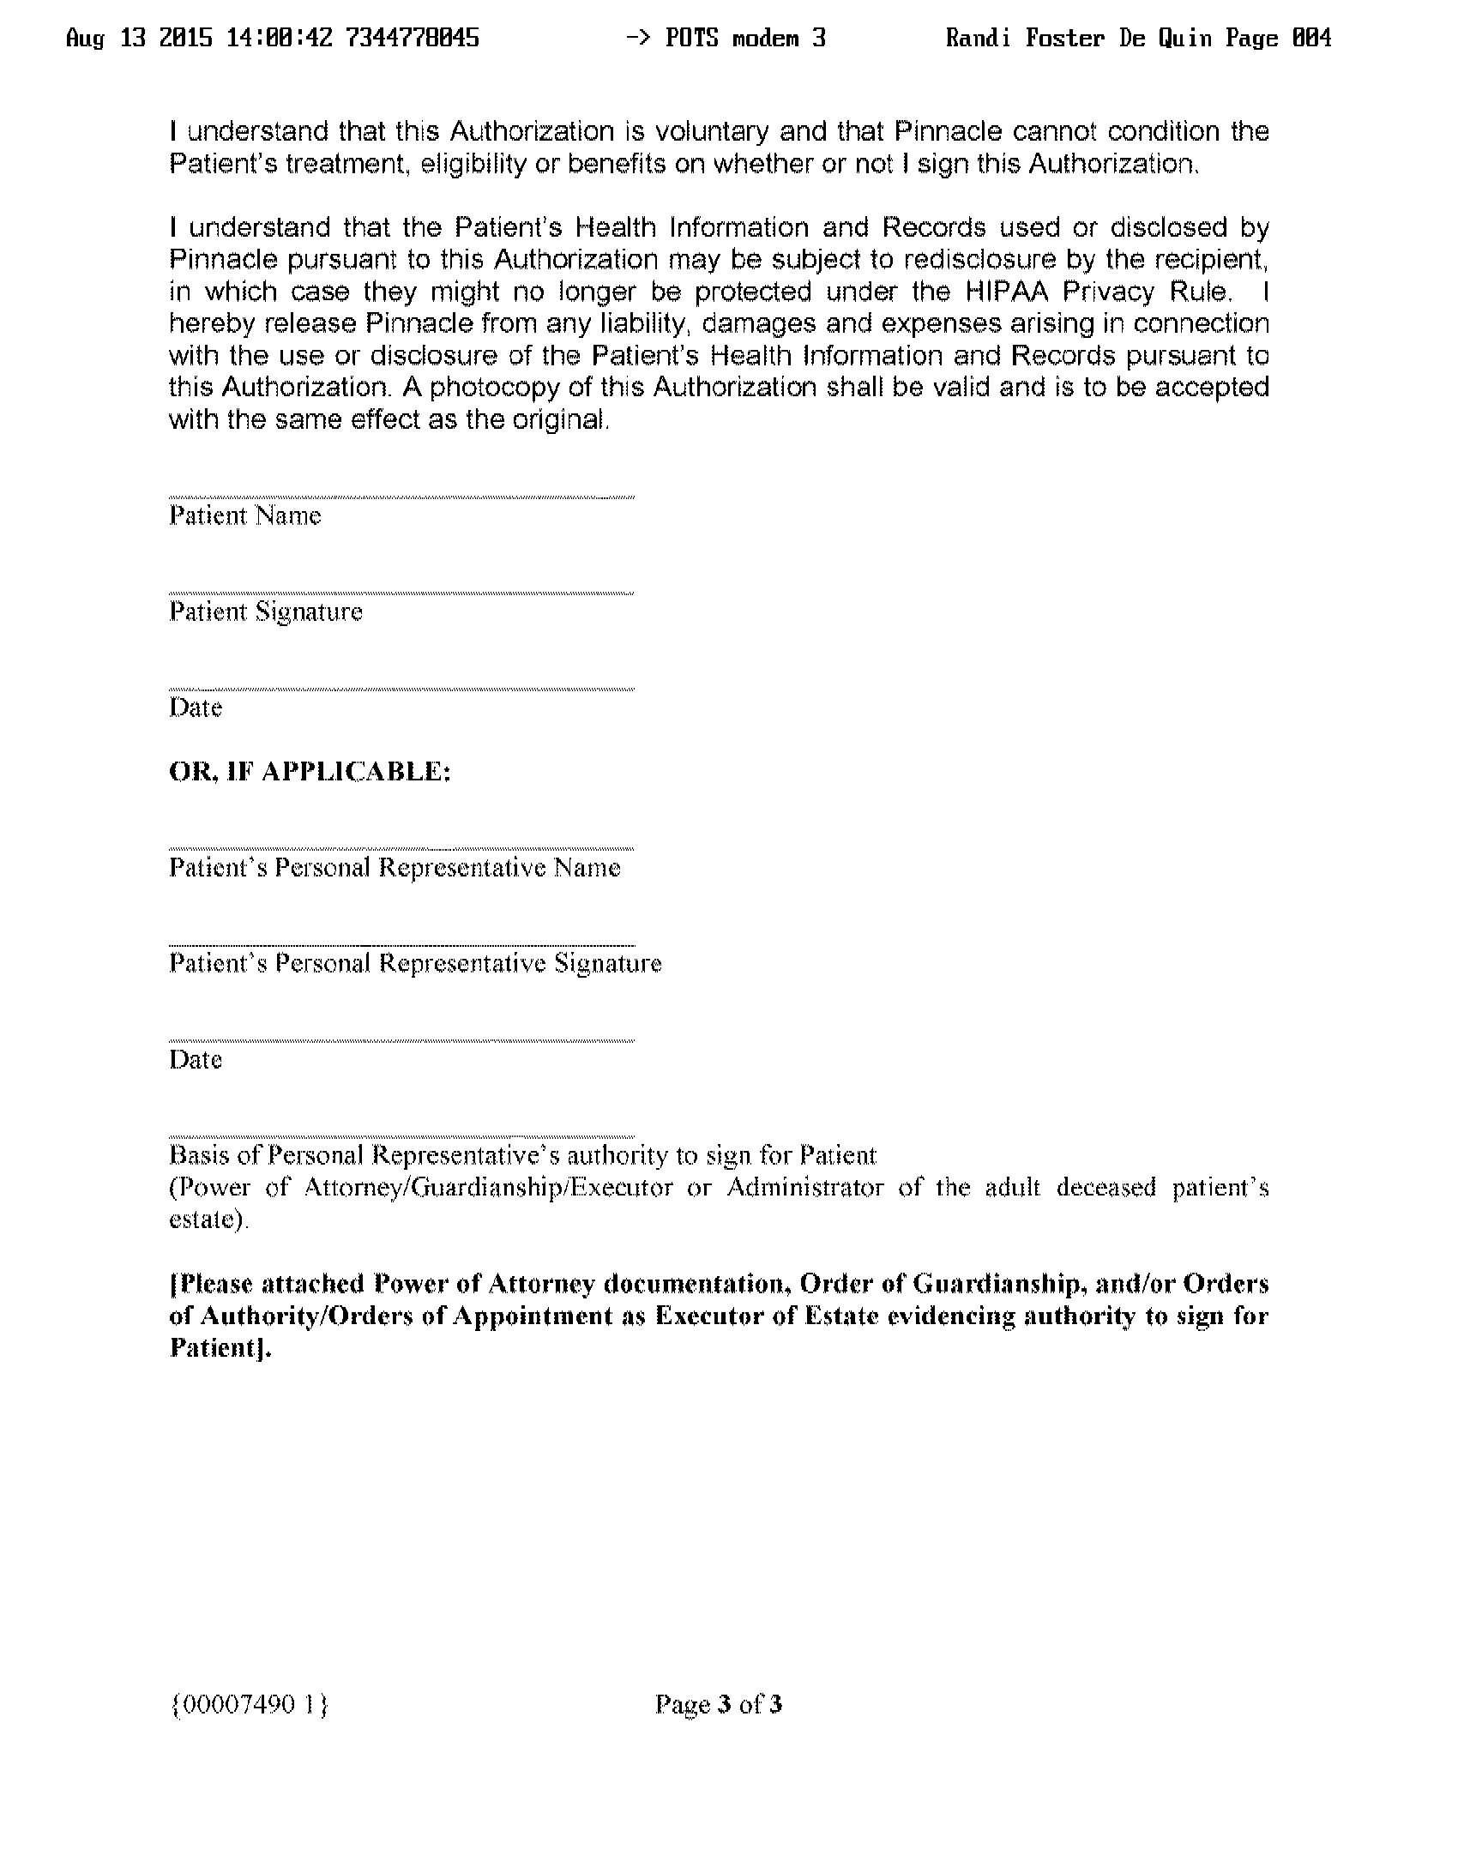

Order Number 01-34762-001
Patricia Martell

